Task / Work activity /operation Description: | Location: | Date of assessment: | Review date:
Task / Work activity /operation Description: | Expected Attending: | Assessor: | Signature:

Number | Hazards:  e.g. Trailing cable | Persons & numbers exposed | Harm:  e.g. Tripping over cable and spraining ankle. | Risk Rating  Without Controls |  |  | Controls:  E.g. re route cable or cover with cable tidy | Risk Rating  With Controls
 |  |  |  | L | C | R | Controls:  E.g. re route cable or cover with cable tidy | L | C | R

Further Recommendations
Additional controls that would further reduce the risk if  Implemented in the future. | Date to be Actioned by | Date  Completed

PPE Requirement

 |  |  |  | 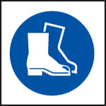 |  |  | 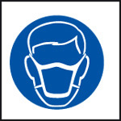 | 

Risk Rating Key
Likelihood (L) x Consequence (C) = (R)Overall Risk Rating
1 Very Unlikely 1 Insignificant 17-25 Unacceptable
2 Unlikely 2 Minor 10-16 Tolerable
3 Fairly Likely 3 Moderate 5-9 Adequate
4 Likely 4 Major 1-4 Acceptable
5 Very likely 5 Catastrophic

Checked by: Signature: Position: .

