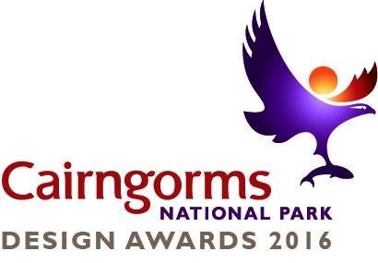
Cairngorms National Park Design Awards 2016 – Entry form

Project Name
Click here to enter text.
Name of Organisation / Person submitting entry
Click here to enter text.
Contact Address
Click here to enter text.
Contact Telephone Number
Click here to enter text.
Contact Email address
Click here to enter text.
Are you the project owner?
Yes ☐ No ☐ Part owner ☐
If you answered no, do you have the project owner’s consent to enter it?
Yes ☐ No ☐
Please select the type of project (you may tick more than one box):
Residential ☐ Landscape Design ☐
Commercial ☐ Public Realm ☐
Community ☐ Other ☐

Project Start date Project Completion date
Click here to enter a date.
Click here to enter a date.
Briefly describe the project (max. 400 words).
Click here to enter text.
Describe how your project’s design process has delivered good design (max. 400 words).
Click here to enter text.
Describe how the project has been successful (e.g. costs, sense of place, inclusivity, sustainability) (max. 400 words).
Click here to enter text.
Entries can only be for projects that:
- Are within the Cairngorms National Park;
- have the required consents (e.g. planning permission, listed building consent etc.); and
- are complete.
Entries must include the following supporting information (tick if included):
- Three high-quality photographs, photomontages or concept drawings of
project (combined file size no more than 6MB) ☐
- Relevant elevation drawings and floor plans ☐
- A site plan ☐
The Cairngorms National Park Authority may use all submitted material for the promotion of the Design Awards.
How will entries be judged?
The Design Awards have a two-stage judging process with an initial shortlisting in September for finalists followed by selection of winners. The Judging Panel’s decisions will be final. The following criteria will be used to shortlist and judge entries.
- Contribution to sense of place and the special qualities of the National Park
- Form of the development – including scale, massing, siting, design, detailing and materials
- Inclusivity of design or meeting the specific needs of the user
- Environmental sustainability and energy efficiency
- Use of local materials and skills
- Creativity / innovation
Award Ceremony
Shortlisted entries will be invited to an awards ceremony in November 2016 where the winners will be announced.
Entering
Send your completed entry form and supporting material to planning@cairngorms.co.uk or to: Design Awards, Cairngorms National Park Authority, 14 The Square, Grantown-on-Spey, PH26 3HG. Incomplete entries will not be accepted.

If you have a question about the Design Awards, you can call 01479 873535 and ask for one the Design Awards team.
The closing date for entries is Friday 1 July 2016.

